Project Report

Project Overview
Breast cancer, affecting 2.2 million individuals annually, is the most prevalent cancer worldwide. Early diagnosis significantly improves survival rates, and a key challenge lies in distinguishing between benign and malignant tumors.
Machine learning (ML) techniques have demonstrated the potential to dramatically enhance diagnostic accuracy, with research revealing a 97% success rate compared to 79% by experienced doctors.
By integrating advanced computational models, we seek to achieve early and highly accurate diagnosis of breast cancer patients, thereby reducing waiting times and minimizing human and technical errors in the diagnostic process. This predictive model aims to assist doctors in efficiently diagnosing breast cancer and enable patients to receive early treatment.

Objectif
Propose method of breast cancer prediction with data exploratory techniques using machine learning classifier in order to have more than 94% success rate accuracy model.

Description
Breast cancer is a cancer that develops from breast tissue.
The external signs of breast cancer may include a lump in the breast, a change in breast shape, dimpling of the skin, milk rejection, fluid coming from the nipple, a newly inverted nipple, or a red or scaly patch of skin .
The internal signs affect the size ,the form and the characteristic of the tumor.
They are a pictures showing the difference between a Benign and Malignant Tumors
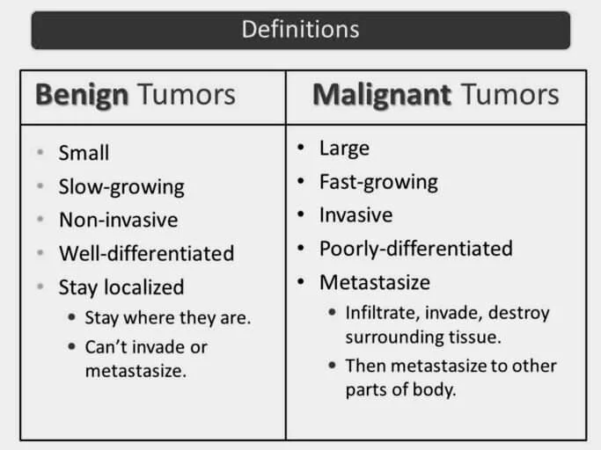
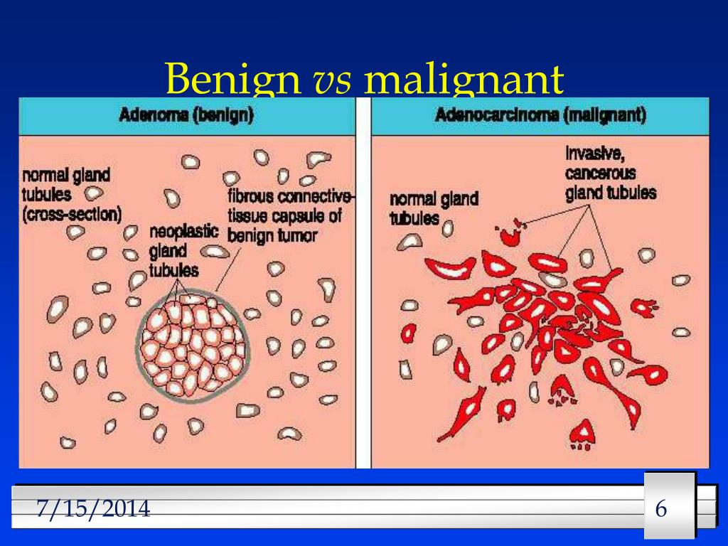
Analyse breast tumours by Machine Learning
Our workflow ensures an approach to breast tumor analysis, from data collection to deploying a predictive model for real-time predictions on new data. We divided on 7 steps :

1- Dataset Collection
2- Data Preprocessing DP
3-Exploratory Data Analysis EDA
4-Classification of prediction on 3 models SVM,NN,KNN
5-Performance Evaluation
6-Best Model Generated
7-Predict on new Data
Schematic workflow diagram

Classification of prediction on 3 models
SVM,NN,KNN

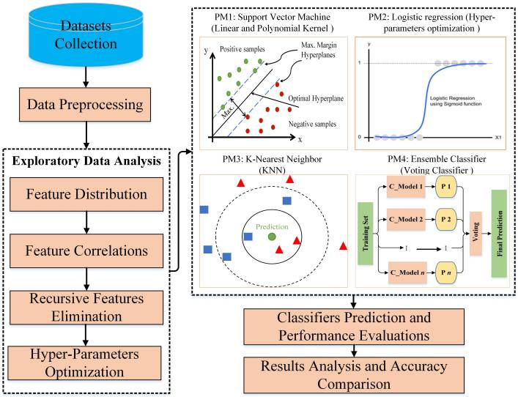
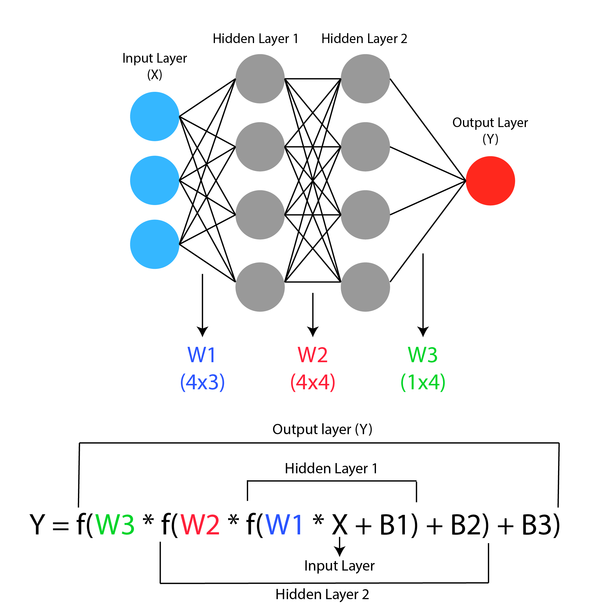
Predict in new data
PM2:NN

Visualize key features

Features distributions

Features Correlation
Data Prepocessing
Performance Evaluation
Best Model Generated

Schematic workflow diagram

- Flow Implementation
The implementation is deeply explained on the githup repo
https://github.com/fahr-khadija/Breast-Cancer-ML

- Results Analysis And Decision
In our work , we used NN, SVM, and KNN three machine learning techniques to early prevention and detection of breast cancer to find which method performs better that we can used to predict the new data.
1-Analyze the performance and evaluation
- Tableau for accuracy

Accuracy |  | NN  Neural Network | SVM  Support Vector Machine | KNN  K Nearest Neighbors
Model | Test | 94% | 93% | 92%
Model | Train | 98% | 98% | 100%
Model  Optimize | Test | 92% | 94%
Model  Optimize | Train | 100% | 99%

- Machines learning techniques performance
-------------------------------------------------------------------------------
Neural Network (NN):
Results
Before Optimization:
Test Set: Accuracy: 94.32%,Loss: 0.1303
Training Set: Accuracy: 98.47% ,Loss: 0.0669
After Optimization:
Test Set: Accuracy: 92.05%,Loss: 0.3176
Training Set: Accuracy: 100.00%,Loss: 0.0026
********
Analysis:
The neural network performs well on the test and training sets before optimization.
After optimization, there's a decrease in test accuracy, indicating potential overfitting during optimization.
However, the training accuracy reaches 100%, suggesting the model might be overfitting to the training data.
-------------------------------------------------------------------------------
Support Vector Machine (SVM):
Before Optimization:
Test Set: Accuracy: 93.18%
Training Set: Accuracy: 98.47%
After Optimization:
Test Set: Accuracy: 94.32%
Training Set: Accuracy: 99.24%
********
Analysis:
The SVM performs well on both the test and training sets.
Optimization results in a slight increase in test accuracy, indicating improvement.
So we can use the optimized model to predict the new Data
-------------------------------------------------------------------------------
K Nearest Neighbors (KNN):
Test Set:Precision: 92%,Recall: 92%,F1-score: 92%,Accuracy: 92%
Training Set:Precision: 100%,Recall: 100%,F1-score: 100%,Accuracy: 100%
********
Analysis:
KNN performs well on both the test and training sets, achieving high precision, recall, and accuracy.
-------------------------------------------------------------------------------

- Machines learning techniques evaluation
Neural Network (NN) consider the potential overfitting after optimization.we should evaluate
other metrics and consider tuning hyperparameters to improve it .
Support Vector Machine (SVM) appears to be a strong performer, especially after optimization.
The model's accuracy on the test and training sets is relatively high.
K Nearest Neighbors (KNN) performs consistently well, showing high precision, recall, and accuracy.

2-Decision:
SVM and KNN both demonstrate strong performance, but SVM exhibits superior accuracy on both the test and training sets.
Therefore, we have chosen the optimized SVM model for predicting in the new dataset.

- Predict on new Data Analyze

Applying the trained model to real-world cases for diagnosis and decision-making.

Accuracy on new dataset: 0.9497716894977168

